**SYSTEM ANALYSIS AND DESIGN**

**3.1 INTRODUCTION**

System analysis and design can be defined as the process of creating or modifying an information system in order to meet the needs and goals of a given business. It is a process of collecting factual data, understand the processes involved, identifying problems and recommending feasible suggestions for improving the system functioning. The usefulness of the system analysis and design process is to aid in building a better system. All necessary requirement or functionality of the proposed system would be taken into record and would serve as a guide in designing the system.

System analysis consist first of studying the current system, that is, if there is one, for it is difficult to design a new system without thoroughly understanding the old one. In this phase, the current system is studied and alternative replacement systems are proposed. System analysis, then, is the process of gathering and interpreting facts, diagnosing problems, and using the information to recommend improvements to the system.

System analysis is one of the major components of a system development life cycle. Analysis phase seeks to answer the question of who will use the system, what the system will do, and where and when it would be used. The analysis phase has three stages which include the analysis strategy which helps to guide the project team, the information gathering phase (use of questionnaires, interviews) and finally the presentation of a proposal to the project sponsor.

**3.2 DESCRIPTION OF THE PROPOSED**

The proposed system would have the ability to grant unregistered users access to a platform (here being an interactive website) where they can peruse a variety of consumer goods, make choices of goods and add to cart, choose preferred payment methods and submit their selections through the designed interface. The products to be marketed shall span across groceries and day-to-day consumer goods. Customers would have the ability to manage their carts before payment mode is selected. The system would have a database for managing all goods in stock, quantities available and their corresponding unit prices. Another database for managing customer selected carts, assignment of delivery dates and time would also be designed. The system would seek to include at least two payment modes to give customers an opportunity to pay through their most preferred means.

**3.3 SYSTEM DESIGN**

This phase includes the process where the development of the system chosen in the system analysis phase is first described independently of a computer platform (logical design) and is then transformed into technology-specific details (physical design) from which all programming and system construction can be accomplished (Abel, SAAD part 2).

It is further divided into two stages of design, which include; the preliminary or general design and the structure or detailed design.

• **Preliminary or general design:** Here, the features of the new system are specified. Costs of implementing the features of the system and the derived benefits are estimated, therefore, if the project is still deemed achievable, we move to the structure design stage. (Abel, SAAD 1)

**• Structure or detailed design:** At this stage, the design of the proposed system becomes more structured. Structured design is an outline of a system solution to a problem with the same constituents and inter-relationship among the constituents as the original problem.

Also, the design stage consists of selecting the appropriate programming language to use as well as the platform it would run on. (Abel, SAAD part 1)

**3.3.1 DATABASE DESIGN**

To store user information or any information related to the proposed system, a database is needed. Therefore, “promall” is the name of the database that would be used in the design of this system. Promall contains some tables that would aid in keeping user information which are described below.

* Users Info
* Items
* Cart Items
* Transactions
* Items Delivered
* Admin

**USERS INFO TABLE**

Here, details or information regarding the users are recorded.

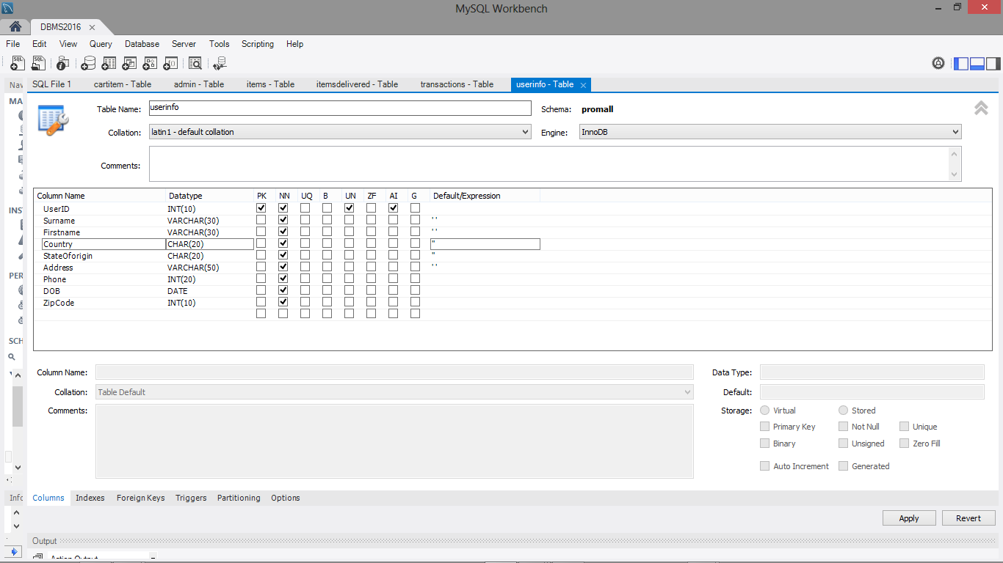

**ITEMS TABLE**

Information regarding the items, their unique identification and their categories are recorded here.

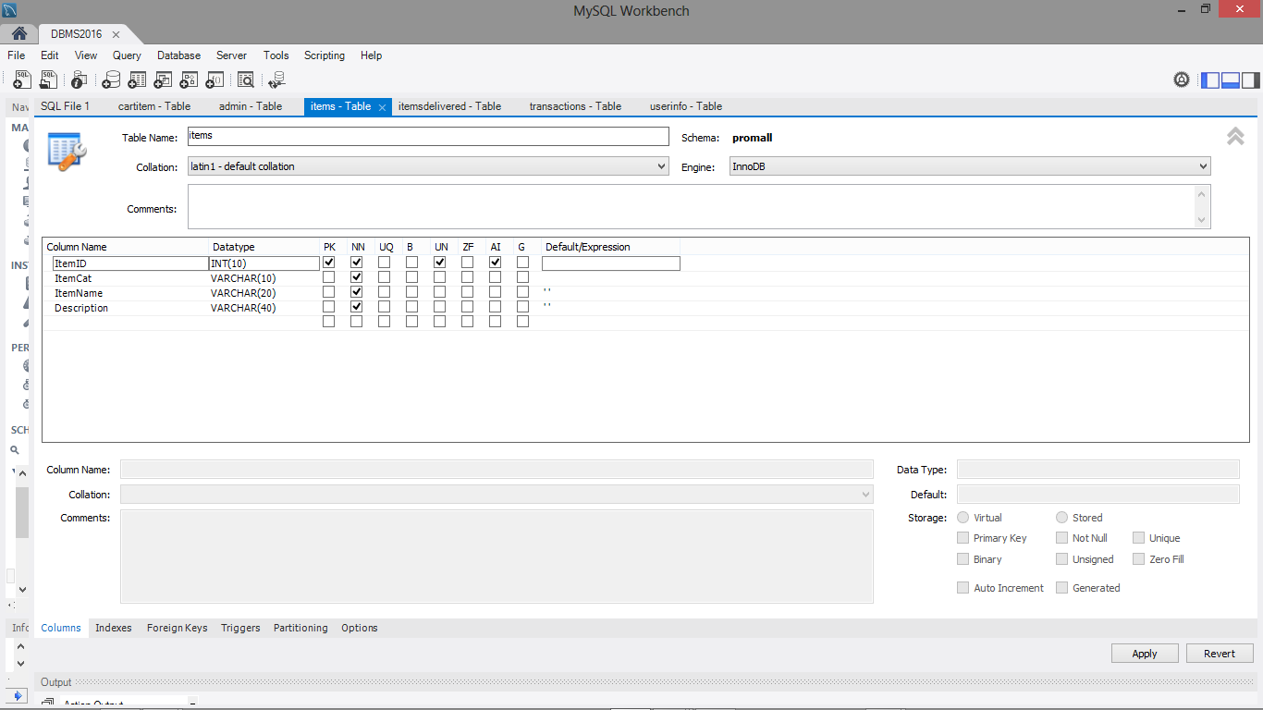

**CART ITEMS TABLE**

The various categories of items picked by each user is recorded here.

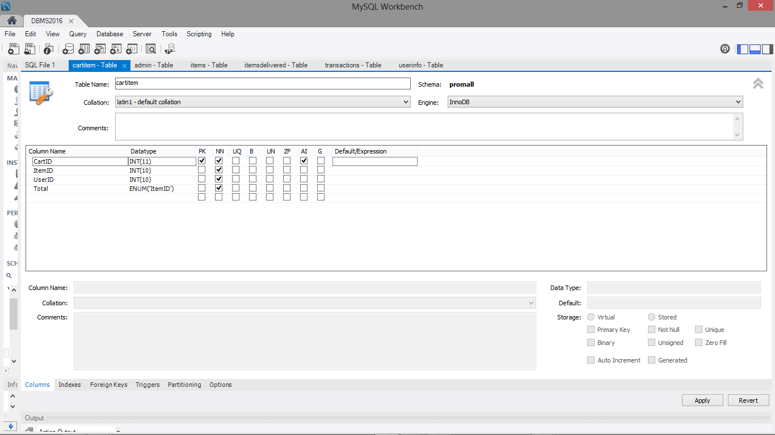

**TRANSACTIONS TABLE**

Amount paid for each item is recorded here.

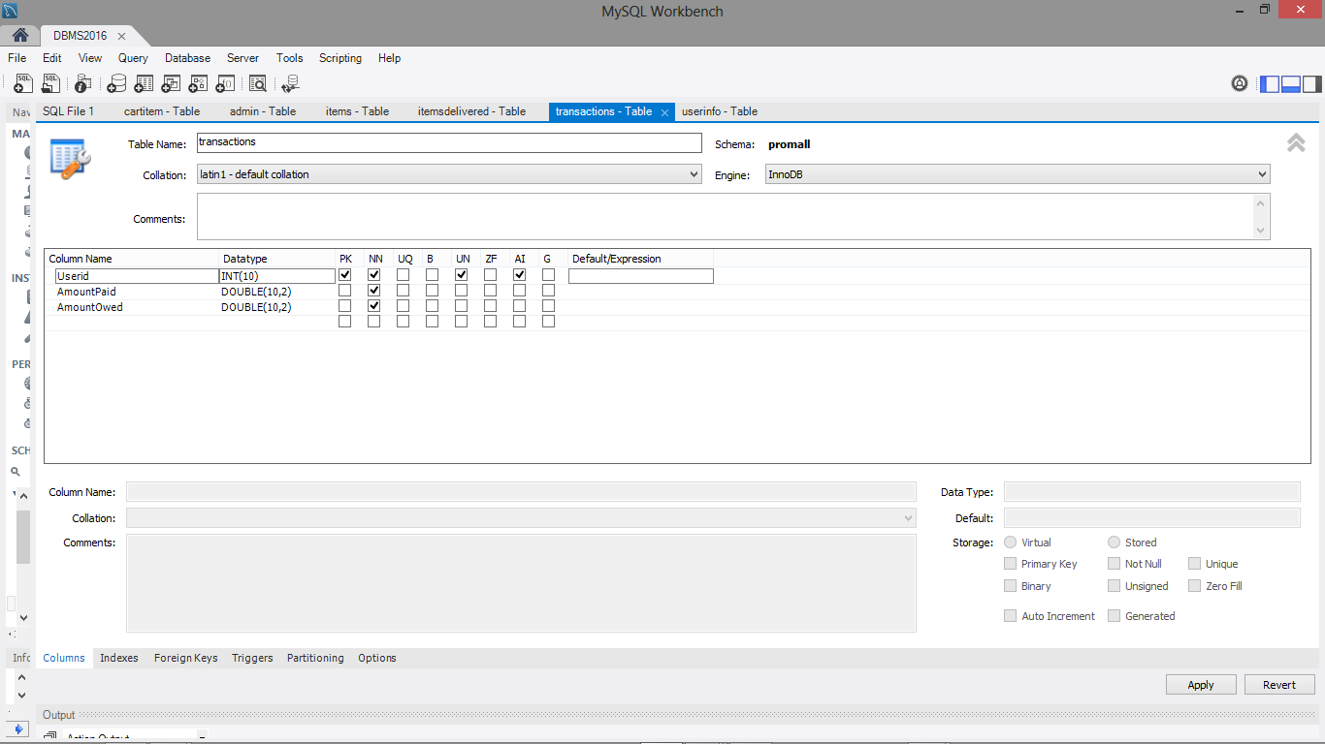

**ITEMS DELIVERED TABLE**

To ensure confirmation of delivery of items to specific users, a table is needed.

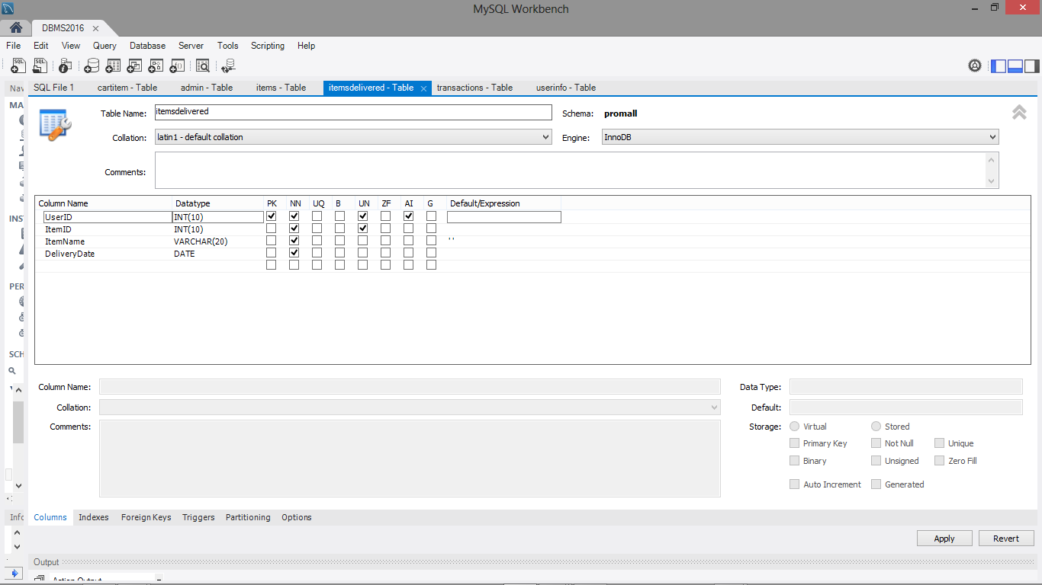

**ADMIN TABLE**

For the different administrators that would be managing and overseeing both the website and database, a table is needed to keep their log in details.

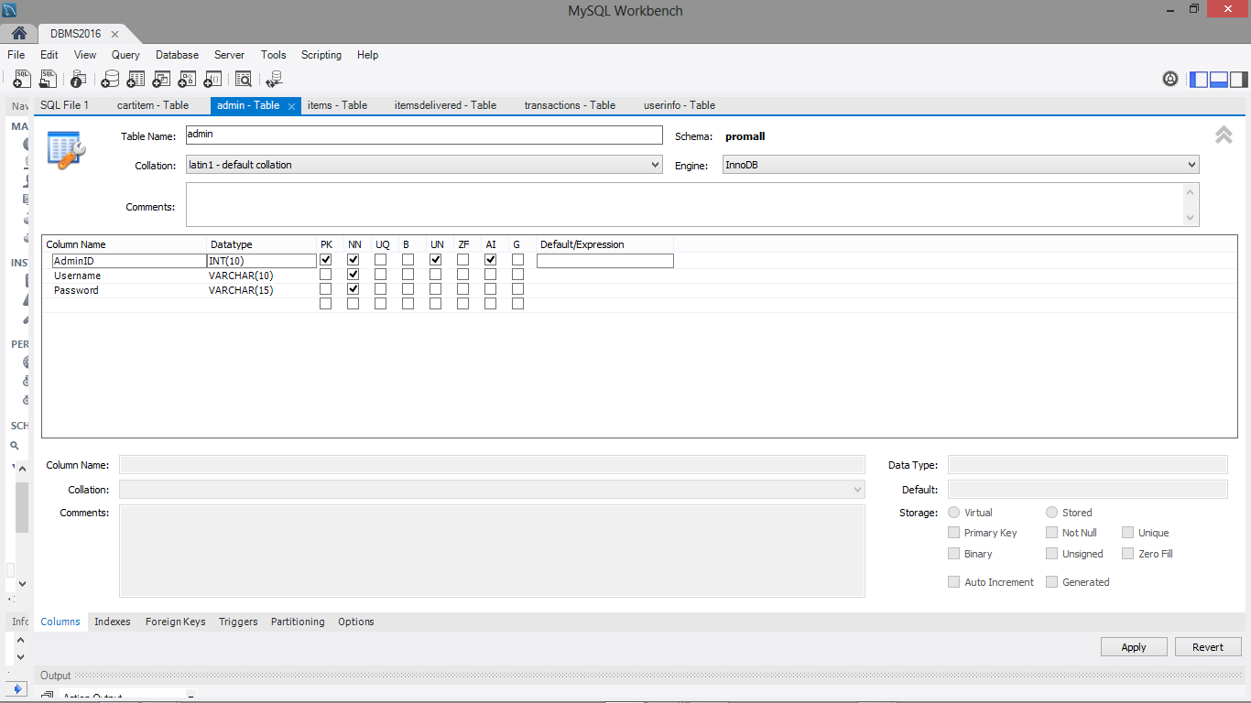

**3.3.2 DESIGN TOOLS**

This project being web based uses the appropriate software applications that would aid in its development. Below are the design tools and programming languages used.

1. **MySQL**

This tool was used to serve as the database management system. The name “MySQL” is also known as My Structured Query Language is a relational database system which allows a website remember information for people. It also has high support in terms of robust transactions, it includes one of the most powerful transactional database engine in the market. It also provides room for strong data protection in which it offers security features to ascertain this possibility. (SITE-PHONE15-16). MySQL also helps to easily establish relationships among tables.

1. **APACHE WEB SERVER**

Apache Web Server is an open source software which protects a websites front end from unauthorized users. Its source code can be tweaked to a user’s preference and by doing this gives it a competitive advantage over its competitors. Apache Web Server has high compatibility with many hardware configurations and operating systems. It can run on Microsoft Windows, Linux, UNIX and so on.

**3.3.3 PROGRAMMING LANGUAGES**

The various web based programming languages used are discussed below.

* **HTML**

Referred to as HyperText Markup Language, is the standard markup language for creating web pages which uses tags to identify its content. Tags that link users to other pages on a website are also available for use in HTML.

* **CSS**

Referred to as Cascading Style Sheets where the term Cascading refers to the way CSS applies one style on top of another while the Style Sheets control the look and feel of web documents. CSS describes how the HTML documents are displayed.

* **JavaScript**

It is a scripting language that allows web server administrators to manage the servers. It was originally developed by Netscape as a means to add dynamic and interactive elements to websites. It provides functionality to HTML pages and it works hand in hand with HTML and CSS to create attractive and interactive websites.

* **PHP**

Referred to as Hypertext Preprocessor. This is a server side scripting language which is built for building logic into web pages. It is used by website developers to enhance functions and appearances of websites and aids in the creation of dynamic web pages which allows communication between the customer and the site. It is also used alongside various web template systems and web frameworks.

Types of system design and their significance [preliminary and structured design]

**3.4 DESIGN COMPONENTS**

Databases shall be organized into tables containing relevant records to enhance management of information received from both the users and administrators. Users of the system being the customers shall be able to place orders using an interactive user interface and their selections shall be received and managed using a database. Also, Administrators shall be able to manage inventory on goods, manage placed orders and determine goods/service delivery methods from the information retrieved from the database. In summary, the proposed system shall be highly driven by databases. Details of database contents shall be unreeled during the actual system design phase.

**3.5 INTERFACE ORGANIZATION AND OUTPUT DESIGNS**

For the sake of convenience and ease of use Graphical User Interfaces shall be employed to enable users interact with the system. Web pages shall be designed and formatted using the Hypertext Markup Language (HTML 5) and the intended choice of a styling sheet shall be the Cascading Style Sheet (CSS) for beautification of web pages and elements within the web page. Users shall have the ability to navigate around web pages and access contents on the shopping mall without any session constraints.

**3.6 REQUIREMENTS ELICITATION**

This encompasses both User and System requirements. User requirements are those things that users expect the system to be able to. For this shopping mall, the user requirements include:

**3.6.1 USER REQUIREMENTS**

1. Users should be able to access the shopping mall for free without login authentication;
2. Users should be able to peruse various categories of goods and add choice goods to their carts;
3. Users should be able to register before submitting their cart;
4. Users should be able to make a preferred choice out of a list of payment mode alternatives (e.g pay-on-delivery, card payments, PocketMoney, etc);
5. Users should get notifications on exact times to expect order deliveries or within a stipulated time range;

**3.6.2 SYSTEM REQUIREMENTS**

These include functional and non-functional requirements. Functional requirements are the statement of services the system should provide (Olusoga lecture notes). Relevant to this system include:

1. Products selected should be added to cart (virtual shopping basket);
2. The system should be able to remove a product from the cart upon user request;
3. The system should be able to allow registration of users;
4. The system should be able to manage registered user accounts;
5. The system should be able to determine stock out of products when the inventory of such goods have been exhausted;

**3.6.3 NON-FUNCTIONAL REQUIREMENT**

Non-functional requirements define system properties and constraints on functions offered e.g reliability, response time, etc. (Olusoga lecture note). As pertains this system, the non-functional requirements include:

1. The system should be available for use by users for selection of goods for purchase all day, through the week;
2. The system shall only assign delivery times between the hours of 6:00am through 10:00pm

**3.7 FLOWCHART**

A flowchart is a graphical tool used to show the stepwise procedures involved in completing a process. Each step is represented by different flow symbols. Below is a flowchart outlining the steps a customer would take to complete a shopping process on the proposed shopping mall.